MC900299493[1]MC900138275[1]

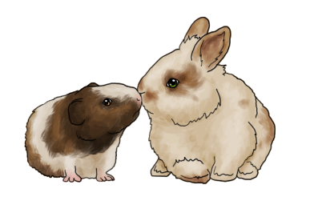**Meet, Greet and Learn about Small Animals**

By John Haggerty, Small Animal Chair

**SAVE THE DATE!!!!**

When:   Sunday, April 6, 2014

Time: 12:00 noon until 5:00PM

Where:   San Martin Lions Club, San Martin

Who: 4-H youth, 4-H volunteers & parents

We are inviting all 4-H youth who own small animals and/or those considering owning small animals.

At this event, you will meet a small animal veterinarian and our knowledgeable small animal chairpersons. They will help answer your questions.

There will be resource material available on various animal species which should be helpful to any small animal project and teen leaders.

Additionally, in preparation for the 2014 Fair, experienced youth will demonstrate showmanship with dogs, rabbits, cavies, poultry and pygmy goats. Lunch (pizza and drinks) will be provided. More details will be sent out as the event’s agenda is developed.

In this edition

Event Calendar Pg. 2

Youth in Action Pg. 2 - 3

County Events Pg. 4

County News Pg. 5 - 7

Resources Pg. 7 - 10

State News Pg. 10 - 11

Scholarship Pg. 12

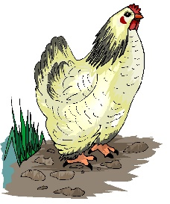



**Youth in Action**

**UPCOMING COUNTY EVENTS**

**3/11** Full County Council Meeting

Berger Drive Auditorium

7:15pm to 9:15 pm

**3/15** Favorite Foods Day

Berger Drive Auditorium

8:30 am to 1:30 pm

**4/12** Fashion Revue

Berger Drive Auditorium

9:30am Check-in

10:00am Judging starts

**4/8** Executive Council Meeting

Berger Drive Auditorium

7:15pm to 9:15 pm

**6/24-** 4-H Summer Camp

***For more information on upcoming 4-H events visit us at www.SCC4H.org***

**Leadership Overnight**

By Eileen Hails, Rolling Hills 4-H

February 7, 2014, I went to Leadership Overnight (LON). We stayed in cabins at Walden West. I found it to be an interesting, fun-filled, and eventful weekend. There were sessions on many different topics, including a 4-H alumni, bullying, and different life skills.

I think my favorite sessions were either the colors session, the event planning, or the Seniors Q&A. In both the colors and event planning, we split up into groups to plan an event. The Senior Q&A was a time where we could listen to the eight seniors/ graduates. They talked about their paths through 4-H, favorite memories, and their role models.  What most of them probably don’t know is that some of them are our role models.

The dance on Saturday night was also super exciting.  We learned how to swing dance!  Despite the rainy weather, we all had a great time.  I really enjoyed the weekend, and the All Stars Tevy and Jackie did a nice job putting on the event!

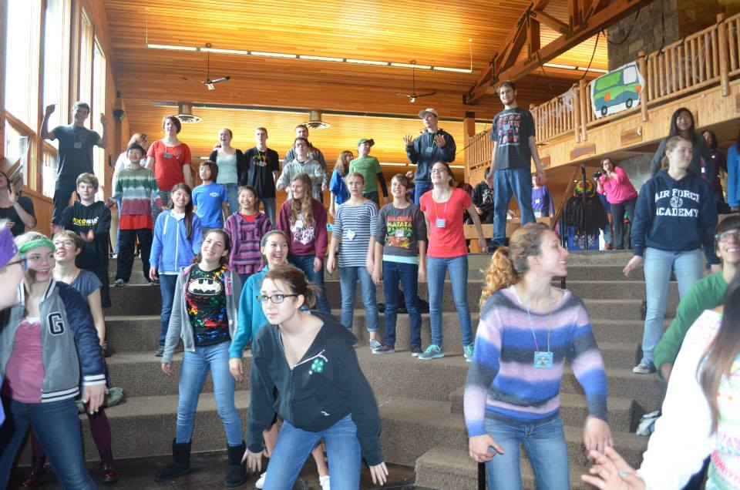

*Our 80’s workout session**at LON*

**Horse Project Meeting**

By Alexander Call, El Sereno 4-H Club

At the El Sereno 4-H horse project meeting, Alysia made a presentation on horse parasites and quizzed us afterwards. I learned about mostly internal parasites, which are parasites that spent their life inside their host animal. I didn’t learn as much about external parasites, which are for example, ticks. We learned about ways parasites latch onto a horse and their symptoms. Mange mites can cause symptoms such as scraps of fur missing, normally on the base of the tail, but in serious conditions it could be all over the horse.

I think we all learned a lot from this meeting, because we quizzed and quizzed until we knew the answers (at least most of the time). For getting the answers right, we got a piece of candy, and for no apparent reason, we called dum-dum lollipops ‘smart-smarts’, but maybe it was because we thought that you are smart if you get the question right, and it’s not very appropriate if the lollipops are called dum-dums!

I think this meeting will make the Santa Clara team a lot stronger for the horse classic!

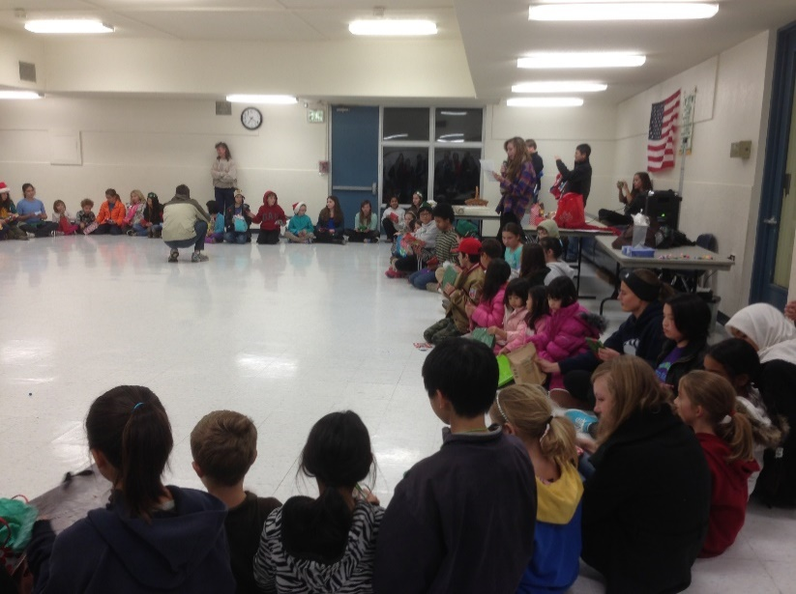**Gift Exchange Program**

By Jada Ho, Rolling Hills 4-HClub

At the December Rolling Hills 4-H General meeting, the executive board planned a gift exchange. Every youth brought a small wrapped gift to the meeting. Participants sat in a circle as our club president read a story. When either “right” or “left” was mentioned, all of the youth would pass the gift they were holding to their neighbor in that particular direction. After the story ended, you could open the gift in your hands. I unwrapped mine to find a Mario keychain, which I was not particularly fond of. So I traded it for a game of Hedbanz. Personally, I think that the December Gift exchange is the most exciting program of the year.

**County Events**

**4-H Favorite Foods Day: March 15, 2014**

***Favorite Foods Day*** is a county wide event held once a year to provide a “Learn by doing” educational experience for 4-H youth members. Emphasis is on meal preparation, nutritional knowledge, menu planning, food safety, table setting, and appropriateness for occasion and *Favorite Food* item. Members are advised to make a product appropriate for their age. Advanced members are expected to prepare foods that take extra time, preparation and skills.

**Where:** 1555 Berger Drive, Building 2 Auditorium

**When**: March 15, 2014. 8:30 am to 1:30 pm

**4-H Fashion Revue & Design Contest: April 12, 2014**

***Fashion Revue*** is a county-wide event held once a year for 4-H youth to model an outfit or garment they may have made or purchased. The primary purpose is to build self-confidence in young people by helping them find the style that suits them best and work on grooming, posture and stage presence. This event is open for all 4-H members.

**Where:** 1555 Berger Drive, Building 2 Auditorium

**When:** Registration 9:30 AM/Judging 10:00 AM

***Categories:***

*Traditional ● Upcycled ● Denim Challenge ● Apron Challenge • $40 Purchased ● $100 Purchased (not eligible for State Fashion Revue)*

*Please check the State 4-H web-site for more information on each category.*

*Something* ***NEW*** *is happening at the Santa Clara County 4-H Fashion Revue this year. Robin Sando, California "Make It With Wool" director, is donating a piece of wool fabric to the best overall wool outfit.*

***Service Learning Project at Fashion Revue:*** *We are making drawstring bags for foster children and walker/wheelchair bags for seniors. Patterns are on the State 4-H web-site:* [*http://4h.ucanr.edu/Programs/Events/SFD/SFR/*](http://4h.ucanr.edu/Programs/Events/SFD/SFR/)

*For more information or questions you can contact Kyle or Dustin Geringer at* [*srgerin225@sbcglobal.net*](mailto:srgerin225@sbcglobal.net) *or Leah or Eileen Hails at* [*khails@outlook.com*](mailto:khails@outlook.com)

*The state "Make It With Wool" contest will be held on November 8, 2014 in San Jose.   For more information, please visit:* [*http://makeitwithwool.com/statecontacts.html*](http://makeitwithwool.com/statecontacts.html)

**SCC 4-H camp : June 24-28, 2014**

*****4-H Summer Camp*** is an opportunity for youth to learn new skills and make new friends. It is open to all 4-H youth members aged 9 and up as of December 31, 2013. Clovers Members, age 5 to 8 years old, can attend camp for 1 day. Online registration will be open soon; camp fees - TBA and financial aid will be available.



**County News**

At the **County Achievement Night** on February 15, we celebrated with many 4-H members on their project proficiency awards and record book awards.

**Club 4-H Member Proficiency**

San Martin Caleb Mabie Bee Keeping

San Martin Elizabeth Widman Bee Keeping

San Martin Camille Widman Bee Keeping

San Martin Ksenia Medvedeva Bee Keeping

San Martin Grace Dudek Bee Keeping

Pleasant Acres Alyssa Long Cavy

Pleasant Acres Austin Long Cavy

Pleasant Acres Jackson Oliver Cavy

Pleasant Acres Lauren Oliver Cavy

Pleasant Acres Darrick Oliver Cavy

Pleasant Acres Jackson Oliver Cavy

Pleasant Acres Faith Roder Cavy

Pleasant Acres Sam Horovitz Cavy

Pleasant Acres Rylie Weaver Cavy

El Sereno Dustin Geringer Clothing

El Sereno Kyle Geringer Clothing

El Sereno Dustin Geringer Clothing

El Sereno Kyle Geringer Clothing

Coyote Crest Joseph Delisle Creative Arts

Coyote Crest Aaron Alger Creative Arts

San Martin Hayden Green Creative Arts

Pleasant Acres Sam Horovitz Creative Arts

Adams Carson Gilroy Dog

Rolling Hills Annie Borders Dog

Rolling Hills Lucy Miller Dog

Rolling Hills Andy Suit Dog

Rolling Hills Theresa Willard Dog

**Club 4-H Member Proficiency**

Rolling Hills Gabriella Fourkas Entomology

Rolling Hills Grant Fourkas Entomology

Rolling Hills Christopher Chapman Entomology

Rolling Hills Nikitha Fernandes Entomology

Rolling Hills Adhithi Fernandes Entomology

Rolling Hills Mateo McCullough Entomology

Rolling Hills Zac Oelke Entomology

Rolling Hills Caroline Spencer Entomology

Homesteaders Jackie Penner Goat

Rolling Hills Maya Nemani Poultry

Rolling Hills Jivan Pannu Poultry

Rolling Hills Jacob Gensheimer Poultry

Rolling Hills Caroline Spencer Poultry

Coyote Crest Adrana Perazzo Poultry

Coyote Crest Aaron Alger Poultry

Coyote Crest Maria Rauwolf Poultry

Rolling Hills Annie Borders Poultry

San Martin Ksenia Medvedeva Poultry

San Martin Ksenia Medvedeva Poultry

Rolling Hills Caroline Spencer Pygmy Goat

Rolling Hills Jada Ho Pygmy Goat

Rolling Hills Astoria Ho Pygmy Goat

Coyote Crest Paula Piva Rabbits

Rolling Hills Jada Ho Sheep

Rolling Hills Ethan Ho Sheep

Rolling Hills Astoria Ho Sheep

**4- H Adult Volunteers are vital to our 4-H program,** contributing their time and talents in enriching young people’s life. Besides taking the opportunity to thank adults for their years of volunteering in 4-H, nominations were also solicited for the following five categories:

**INNOVATOR AWARD** - adults who developed new programs, county projects, or activities.

**RECRUITMENT AWARD**- adults who have undertaken recruitment efforts that attracted new members.

**LEADERSHIP DEVELOPMENT AWARD** - adults who demonstrated and displayed an ability to develop leadership in youth.

**COMMUNITY SERVICE** - adults who collaborated or cooperated with other community or 4-H groups, or participated in service projects and activities within their 4-H club or group.

**EXCEPTIONAL SERVICE AWARD** - adults who have gone above and beyond in developing or promoting the 4-H Youth Development Program.

And the Awards went to…

Cheryl Beyer of Adams 4-H

Jeannie McDevitt of Adams 4-H

Stan Alger of Coyote Crest 4-H

April Croce of Coyote Crest 4-H

Evelyn McGarry of Coyote Crest 4-H

Bud Bertram of Homesteaders 4-H

Chuck Yoders of Homesteaders 4-H

Chris Allan of Homesteaders 4-H

Linda Teagle of Rolling Hills 4-H

Erin Cizan of Rolling Hills 4-H

Mary Bartlett of Rolling Hills 4-H

Susan Weaver of Pleasant Acres 4-H

Patti Hares of Pleasant Acres 4-H

Susan Horovitz of Pleasant Acres 4-H

**How to Join the SCC (Santa Clara County) 4-H Yahoo Group**

By Hans Toensfeldt, Yahoo group moderator

Would you like to learn of 4-H news when they become available? Would you like to exchange ideas and information with other 4-H members? To be added to the 4-H Yahoo group, a list serve that is managed by and for 4-H volunteers and youth, I need to send out individual invitations to confirmed 4-H members or 4-H volunteers.  
  
If you would like to be added to the 4-H Yahoo Group, I need your Club Leader or Volunteer Enrollment Coordinator to confirm you are indeed a 4-H member or a 4-H volunteer, before I send out the invitations to join the group. New 4-H members and families: Please contact your enrollment coordinator to request scc4h yahoo group membership.

**Resources for 4-H Volunteers**

**Water Education/Projects**

Help bring awareness of water shortage in CA. Here are useful resources that you can use to teach water conservation:

**There’s No New Water! 4-H curriculum (6-10th grade)**

*There’s No New Water!* is a water conservation and water quality curriculum grounded in a simple yet powerful concept that water is a finite natural resource whose quantity and quality must be responsibly preserved, protected, used, and reused. The *There’s No New Water!* curriculum is designed for middle and high school age youth, with six sequential learning modules. The curriculum is intended for delivery in out of school group settings and facilitated by an adult.

$16 | <http://www.4-h.org/resource-library/curriculum/4-h-theres-no-new-water/>

**4-H2O Curriculum: Water Quality Awareness in Urban Environments**

This curriculum also teaches young people about water conservation and quality, It is aimed at elementary school aged children. Teens can serve as teachers to younger children.

<http://www.ca4h.org/files/14369.pdf>

Continued on Page 8

**2008 4-H National Youth Science Day: Helpful Hydrogels**

Can hydrogels help the environment? Water is everywhere – in the sky, in the ground, and in our homes. However, caring for this vital resource is often a challenge for each of us. Conservation means using water wisely. Protecting our groundwater is important because it is a source for drinking and [irrigation](http://4h.ucanr.edu/Projects/SET/NYSD/2008_4-H_NYSD/). Consequently, scientists and engineers have developed amazing, superabsorbent polymers, called hydrogels,that can help.

These activities are aimed at elementary school aged children. Teens can serve as teachers to younger children.

<http://4h.ucanr.edu/Projects/SET/NYSD/2008_4-H_NYSD/>

**4-H Project Sheet: Water Education**

This project sheet takes the concept of water education and links it to science, engineering and technology, healthy living, citizenship and leadership. Learning concepts are divided for beginners, intermediate and advanced learners. It includes links to helpful resources and curricula.

<http://4h.ucanr.edu/files/160007.pdf>

**4-H2Online from National 4-H Council**

4-H2Online - a community for youth to learn about water quality, water conservation and watershed issues. Throughout this site you'll find 4-H's “Exploring Your Environment” Grab-n-Go's and information on how youth nationwide are addressing water issues in their communities. Get started by watching the vodcast series "A Day Without Water" to learn more about how you can make an impact in your community!

<http://www.4-h.org/youth-development-programs/4-h-science-programs/environmental-science-alternative-energy/4h2online/>



**Emergency Preparation & Response Guideline (Clover Safe)**

Accidents happen. The following information is a good reminder of information to know in case of an emergency.

**Introduction**

Although University of California 4-H YDP activities are planned and conducted to eliminate risk of injury to participants, unforeseen accidents periodically occur whereby injuries are sustained. When an injury occurs, 4-H YDP volunteers and staff need to be prepared to provide an appropriate emergency response to the type and extent of a participant’s injury. This Clover Safe describes how to prepare for and respond to an injury emergency Continued on Page 9

**Emergency Preparation**

4-H YDP volunteers and staff should be prepared for potential participant injuries by:

* Being capable of distinguishing between life threatening and non-life threatening injuries.
* Being competent to determine whether an injury requires immediate Emergency Medical Services (EMS) evacuation or other transportation in a passenger vehicle to a hospital or clinic.
* Knowing the location of and route to the nearest hospital or clinic.
* Having a telephone (cellular or land-line) to be able to immediately communicate with EMS. Dial 911, but remember that some phone systems require you to first dial an outside line.
* Maintaining a confidential youth or adult Medical Release Form for each participant in a 4-H event or activity.
* Knowing whether any participants have special medical conditions stated on the Medical Release Form (such as severe allergies or diabetes) that may require emergency medication or other assistance.

**Primary Emergency Response**

4-H YDP volunteers and staff should provide a primary emergency response as follows:

* Evaluate the situation and if a serious injury has occurred, contact EMS.
* Stabilize the situation.
* Evacuate other event participants if a serious hazard continues to exist.
* Provide basic first aid to the extent you are trained.

**Secondary Emergency Response**

4-H YDP volunteers and staff should provide secondary emergency response as follows:

* Once EMS has arrived, provide assistance as requested or needed.
* Act as a resource to EMS or responding agency (police, fire dept., etc.)
* Manage other 4-H members and/or event participants to prevent additional injuries.
* Report any injury to the 4-H member’s parent/guardian/emergency contact.
* Report any injury and circumstances of the incident to their immediate supervisor and 4-H YDP staff.
* 4-H YDP staff will report any injury through their chain of command until an administrator such as the Cooperative Extension (CE) County Director, Regional Director, or State 4-H Director is notified.

**Incident Reporting Procedures**

* 4-H YDP volunteers or staff are not expected to conduct any investigation of a serious injury or incident. Any investigation will be conducted by the responding agency (police, fire, etc.) or directed by ANR Risk Services.

Continued on Page 10

* 4-H YDP volunteers and/or staff will complete an Incident Report form for all injuries regardless of seriousness and submit the form to the CE/4-H county office and CE Director and/or 4-H staff within 48 hours of the incident. Incident Report forms are available from the CE county office or online at: <http://ucanr.edu/incidentreport>
* CE county offices will keep a copy of the Incident Report and forward it to ANR Risk Services within two working days of the incident.
* Contact ANR Risk Services at (530) 752-7481 or ANR Environmental Health & Safety at (530) 752-6024 for help with the Incident Report form.

State News & Events

**Ag Day at the Capitol**

**Wednesday, March 19 10:00 a.m. -1:30 p.m.**

West lawn of the State Capitol Sacramento, California

We will be celebrating on the Capitol lawn with assembly members, senators, and other government agencies. 4-H will have multiple activities going on, such as 4-H animals and Eco bots, so if you would like more information or are available to participate for community service please contact **Sarah Watkins**, spwatkins@ucanr.edu

**Add your voice by March 10th to the State 4-H Future’s Task Force**

The State 4-H office has convened a Task Force that is charged with analyzing our current sectional and state programming and organizational structure and developing recommendations to strengthen, grow, and sustain the 4-H Youth Development Program for the next 100 years. In December 2013, the Task Force met to discuss preliminary recommendations on the areas that had been identified across the state as the top areas of opportunity to make the best better for the future of 4-H. The areas which were discussed were: 4-H Public Relations, Communication, Engagement, and Organization

Your comments on this topic are valuable to the task force. Please either complete the online survey tool <http://ucanr.edu/survey/survey.cfm?surveynumber=11848> or download and complete a word version from our webpage [http://4h.ucanr.edu/Administration/4- H_Futures_Task_Force/](http://4h.ucanr.edu/Administration/4-%20H_Futures_Task_Force/) **by March 10th.**

Join us on Facebook to stay up-to-date on information and join in our discussions: <https://www.facebook.com/groups/148321398700801/>

Continued on Page 11

**4-H Uniform Contest** - If you’ve always wished we could update the 4-H uniform now is your chance to have a voice in changing it! The state 4-H Incentives and Recognition Advisory Committee is facilitating the process to adopt a new uniform. **Proposals are due April 18th, 9pm.**  Read the *rules* of this 4-H uniform contest here: <http://4h.ucanr.edu/files/181544.pdf>

Submit your proposal here: <http://ucanr.edu/survey/survey.cfm?surveynumber=12195>

**The California 4-H Photography Competition** is open to 4-H members (ages 9-19) to showcase their best photographs taken within the past 4-H year. There are no prior requirements to enter at the state level competition. The photography competition is held during the California 4-H State Field Day at UC Davis on **May 31, 2014**.  The entries will be judged in the morning to early afternoon.  After the judging is complete, the doors will be open to the public for viewing.  Best of Show and Best of Division Awards for the photography contest will be announced during the Awards Ceremony at State Field Day.  Award seals will be given at photograph pick up at the end of the day. To learn more about 2014 Photograph Competition: <http://4h.ucanr.edu/Programs/Events/SFD/Photo/>

**The 2nd Annual State 4-H Shooting Sports Archery** Match Rules and Entry Form is now available on the State 4-H Shooting Sports website. **Entry due date is April 1, 2014**. Targets and scorecards will be mailed upon receipt. Individuals may enter traditional and/or compound and three shooting distances. The age categories are junior, intermediate and senior. Completed scorecards must be returned by June 16, 2014. If you have questions, contact **Linda Edgington** at 707-463-4495 or email [lgedgington@ucanr.edu](mailto:lgedgington@ucanr.edu).

**Scholarships**

**Daisy Air Guns** is offering two $500 scholarships for graduating seniors who meet the academic criteria and who have been active in 4-H Shooting Sports. Applications must be received by the State 4-H Shooting Sports Coordinator by **April 1, 2014**. To learn more, see website <http://4h.ucanr.edu/Projects/SET/ShootingSports/>

**The North Central Section 4-H Council** has budgeted up to $1000 for scholarships to be awarded to selected North Central Section 4-H members only. As such, 4-H members from Santa Clara county are eligible to apply. A member may be awarded the scholarship once.

Minimum Qualifications:

* Be a current 4-H member in good standing in a county of the North Central Section.
* Be a graduating high school senior or have passed the CHSPE or GED.
* Must plan to study full time at a college/university, community college, or vocational school of applicant’s choice.
* Must have a minimum of four (4) years of active participation in 4-H, at least two (2) of which must have been during high school.

**Deadline to apply: April 28, 2014**

**To request an application form, please contact Julie Ho 408-282-3116** [**juho@unanr.edu**](mailto:juho@unanr.edu)



TIMELY TOPICS is published monthly through the cooperative efforts of the University of California Cooperative Extension Office Staff and the County of Santa Clara 4-H Adult Volunteers and Youth Members

To learn more about our county events or register online or find links to event’s required forms, go to <http://cesantaclara.ucanr.edu/Youth_Development/Events/>

Fe Moncloa, Editor

4-H Youth Development Program Advisor

(408) 282-3107

[fxmoncloa@ucanr.edu](mailto:fxmoncloa@ucanr.edu)

Julie Ho, Design and Layout

4-H Program Representative

(408) 282-3116

[juho@ucanr.edu](mailto:juho@ucanr.edu)

**Deadline for articles is the 15th of each month**

University of California, Cooperative Extension Office

1553 Berger Drive, Bldg. 1

San Jose, CA 95112

<http://cesantaclara.ucdavis.edu/Youth_Development>

Office Hours: 9:00 a.m. to 5:00 p.m.

Monday through Friday except Major Holidays

ANR programs are open to participants, regardless of their ability to pay. Program fees will be waived or reduced for eligible youth. Please contact your Club Volunteer Enrollment Coordinator if you have any barriers to participation or any special needs.

It is the policy of the University of California (UC) and the UC Division of Agriculture & Natural Resources not to engage in discrimination against or harassment of any person in any of its programs or activities (Complete nondiscrimination policy statement can be found at <http://ucanr.edu/sites/anrstaff/files/183099.pdf> ) Inquiries regarding ANR’s nondiscrimination policies may be directed to Linda Marie Manton, Affirmative Action Contact, University of California, Agriculture and Natural Resources, 2801 Second Street, Davis, CA 95618, (530) 750-1318